2.1 Introduction of Vector-Valued Functions

Definition: A vector-valued function or vector function, is simply a function whose domain is a subset of the real numbers and whose range is a set of vectors. If the vector function maps real numbers to n-dimensional vectors, we write: .

Note: In this class we are most interested in vector functions of the form .

Note: Very strictly speaking, it is a slight abuse to write when the domain of r is not the full set of real numbers. In particular if D is the domain of r and it is a subset of the real numbers but not equal to the real numbers, we should write . We will ignore this subtlety in this class and be aware that only means that the domain of r is a subset of real numbers.

Definition: If a vector function is of the form , then
, , and are called the component functions of .

Note: In this case we have because the real number t gets mapped to a vector .

Example 1: Find the domain of the vector function: .

The domain of the first component function is all t in .
The domain of the second component function is all real numbers.
The domain of the third component function is all t in .

The domain of r will be all the values of t that are in the domain of all three component functions because each component function must spit something out if r is to spit out a vector. So, we take the intersection of all three domains above and we discover that the domain is all t in .

Note: It is important to see that as we graph a vector-valued function in this class we are simply graphing a parametric function in 3-space. Therefore, t will act as a parameter and each vector-valued function will have an associated orientation.
Example 2: We have seen that the parametric equations for the line that passes through the points (2,-3,4) and (4,2,1) are: . How could one represent this line as a vector function?

A vector function for this line would be: .

The instructor will show a computerized graph of this line.

Vector functions of the form are very useful in physics for describing the motion of a particle that moves in a complicated fashion. In this context we usually think of t as representing time, and the position of the particle at time t is the terminal point of the position vector that the function spits out at t. Technology can help us to appreciate the power in this.

Example 3: Sketch a graph of each of the following functions.
- for .

We may immediately note that . Therefore we have the equation .
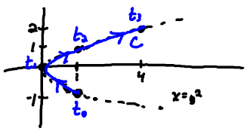

- for .
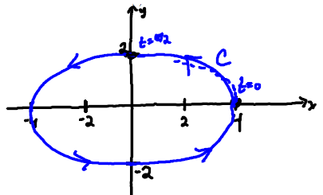

- for .
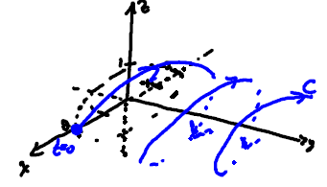

Example 4: Use a computer to graph the vector function:

One should use the free three dimensional plotter (the link is available in Blackboard) to do this. Bounds on t from -3.14 to 3.14 and 200 steps works well. Interestingly, this curve is called a toroidal spiral because it lies on a torus.

Note: One skill that a student should work to develop is the ability to match a curve with a vector function. The next example addresses this.

Example 5: Match each picture below with its appropriate vector function (you are not allowed to use a computer).

Graph A:  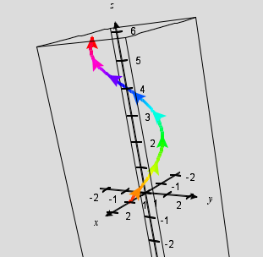 | Graph B: 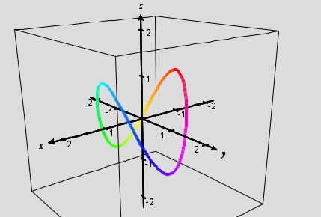

Possible functions:
1.
2.
3.
4.

Graph A should be matched with 1. Graph B should be matched with 2.

